Seeed Studio Music Shield V1.0

<http://www.seeedstudio.com/wiki/Music_Shield_V1.0>

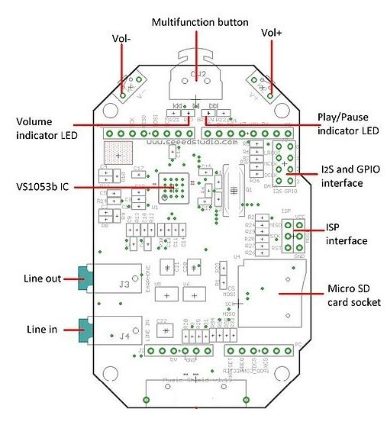

**Multifunction button**: Turn left to play previous song, and right to next song, while pressing it down to pause and resume.

**Volume indicator LED (RED)**: If volume+, the red LED will be brighter.

**Play/Pause indicator LED (GREEN)**: If playing, the green LED blinks.

**Line out** can drive 16 ohm or 32 ohm earphone.

**Line in** is used to record audio from other resources.

**Micro SD card** can be FAT16 or FAT32, and the size more than 2GB is not supported. (PLEASE NOTE: Example code included with library will only use FAT16 formatted cards)

**I2S and GPIO** are for digital audio output.

**ISP interface** is kept for bringing SPI port when using with Mega.

### **Pins usage on Arduino**

**D0** - Unused.

**D1** - Unused.

**D2** - Used for receiving signal from iPod dock(could be used for your own application if iPod dock is not used).

**D3** - Used for receiving signal from button for Volume Up(could be used for your own application if the switch is not used).

**D4** - Used for receiving signal from switch for Next Song function(could be used for your own application if the switch is not used).

**D5** - Used for receive signal from switch for Play&Stop and Record function(could be used for your own application if the switch is not used).

**D6** - Used for receive signal from switch for Previous Song function(could be used for your own application if the switch is not used).

**D7** - Used for receiving signal from button for Volume Down(could be used for your own application if the switch is not used).

**D8** - Used for Green Led instructions(could be used for your own application if the switch is not used).

**D9** - Used for Red Led instructions(could be used for your own application if the switch is not used).

**D10** - Used for SPI Chip Select.

**D11** - Used for SPI MOSI.

**D12** - Used for SPI MISO.

**D13** - Used for SPI SCK.

**D14(A0)** - Used for Reset of VS1053.

**D15(A1)** - Used for Data Require of VS1053.

**D16(A2)** - Used for Data Select of VS1053.

**D17(A3)** - Used for Chip Select of VS1053.

**D18(A4)** - Unused.

**D19(A5)** - Unused.